
Safety Information Bulletin Airworthiness
SIB No.: 2019-07R1
Issued: xx Month 2024

Subject: Sailplane Rigging – Procedures, Inspections and Training

Revision:
This SIB revises EASA SIB 2019-07 dated 30 April 2019.

Ref. Publications:
- Air Accident Investigation Unit of Belgium Final Report AAIU-2010-27 dated 07 January 2011.
- EASA SIB 2011-11 dated 25 May 2011.
- Luftfahrt-Bundesamt (LBA), Lufttüchtigkeitsanweisung (LTA) 1993-001/3 and LTA 1994-001/2, both dated 09 April 1998.
- EASA SIB 2012-04 dated 15 March 2012.
- Bundesstelle für Flugunfalluntersuchung (BfU) Investigation Report BFU18-1190-3X dated 15 April 2021.
- Air Accidents Investigation Branch of the United Kingdom (AAIB UK) Aircraft Accident Report EW/C2017/04/01, Bulletin 3/2018 dated 08 March 2018.
- EASA AD 2018-0081 dated 11 April 2018.
- AAIB UK, Aircraft Accident Report AAIB-25958, Bulletin 6/2020, dated 11 June 2020.
- EASA AD 2020-0260 dated 26 November 2020.
- BfU Interim Report BFU22-0920-3X dated 15 September 2022.
- Bureau d'enquêtes et d'analyses pour la sécurité de l'aviation civile (BEA) Final Report BEA2022-0176 dated 30 August 2023.
- Transportation Safety Bureau of Hungary, Closing Statement 2022-0930-4, dated 11 April 2023.
- AAIB UK, Aircraft Accident Report AAIB-28680, Bulletin 10/2023 dated 12 October 2023.
- Safety Briefing of the British Gliding Association “Is Your Glider Fit for Flight?” dated 28 January 2023.

Applicability:
All sailplanes and powered sailplanes, subject to rigging.

Description:
Statistical data, accident reports, and occurrence reports indicate a number of incidents, which were caused by improper execution of rigging procedures and its subsequent inspection. The number of fatalities linked to improper rigging accumulate to 3 to 4 per year.

The nature of these incidents can be grouped as follows:
- Main wing incorrectly rigged and connected.
- Horizontal stabilizer connected incorrectly.
- Controls not connected or connected incorrectly.
- Control connections not secured or secured incorrectly.
- Pressure probes not installed or installed incorrectly.

Reasons for rigging errors can be grouped as follows:
- Rigging procedure was interrupted; the person executing the rigging was distracted or interrupted, and consequently omitted important steps.
- The rigging procedure was not correctly followed.
- The rigging procedure was not well known by the person executing the rigging.
- The mechanical principles of the connection and/or its securing were not understood by the person executing the rigging.
- Connections and/or securing were not, or incorrectly inspected.
- Positive control check was not performed.

An inadequately connected wing or horizontal stabilizer could lead to its separation from the fuselage, potentially resulting in loss of the sailplane. Inadequate or not connected controls could lead to loss of control of the sailplane.

Since EASA SIB 2019-07 was issued, more accident investigation reports have been published, therefore this SIB revision includes them in the Reference Publications list.
In addition, the recommendation for 'a positive control check' has been even more strongly emphasised. This SIB also recommends operators to establish a procedure for the sign-off of the ‘after rigging inspection’.

At this time, the safety concern described in this SIB is not considered to be an unsafe condition that would warrant Airworthiness Directive (AD) action under Regulation (EU) 748/2012, Part 21.A.3B.

Recommendation(s):
In order to mitigate any safety risk related to the improper execution of rigging procedures and its subsequent inspection, EASA recommends taking the following proactive measures:

Familiarisation With Specific Sailplane Type
The necessary familiarisation with a new type of sailplane should not be limited to ‘how to fly it’, but should also include the rigging of the sailplane. Even if the flight manual offers detailed instructions how to perform the rigging, the familiarisation should be provided by a person familiar with the type of sailplane. This applies in particular to older (vintage) types of sailplanes, where the rigging procedures are not described in detail in the flight manual.

It is recommended that familiarisation with the rigging procedure is provided by a person familiar with the type. This might include repetitive training of some rigging actions.

Avoiding of Interruption and Distraction
Rigging errors, other errors, and omissions in preparing a glider for flight, are frequently caused by interruption, distraction, forgetfulness, and making unwarranted assumptions. EASA stresses the importance of rigging, and performing daily inspections and pre-flight checks, without interruption or distraction.
- Bystanders shall not interrupt people, who are rigging, carrying out daily inspections, or conducting their pre-flight checks.
- Persons, who are engaged in these activities should be assertive and ask not to be disturbed.
- Gliding sites should develop a culture that ensures global awareness of the importance of conscientious rigging, daily inspections, and pre-flight checks.
- It is beneficial to perform double inspection of control connections, before inspection/ assembly holes are closed.
- If rigging is conducted by a team, it should be ensured that one single person is responsible for directing operations of the rigging, and that the loose article (foreign objects) and positive control checks are undertaken.

Positive Control Checks
The vast majority of Aircraft Flight Manuals (AFM) require the execution of a positive control check as part of the rigging procedure and the daily inspection. Most of the AFMs, however, do not indicate how to execute a positive control check.
Even if the AFM does not require positive control checks, it is strongly recommended to perform positive control checks as part of the daily inspection, regardless of whether the sailplane was just rigged or not, or it has automatic control connections.

The positive control check has to involve at least two individuals: one to hold the control surface stationary, while the other attempts to move the flight controls in both directions. It is recommended that the person more familiar with the type performs the check at all the individual control surfaces.

Check steps:
1. The person at the control surfaces commands the person at the cockpit to move the controls into full deflection position and hold it.
2. The person at the control surfaces, gently pushes into the opposite direction., checking for resistance (an indication of correctly connected controls)
3. The above steps should be repeated for both deflections and at control surfaces neutral position, to check for play.

In addition, it should be confirmed that the movement direction of the control surface corresponds with the control input and the full deflection angle is observed. This procedure should be applied for each control surface, including air brakes and flaps.

The procedure should also include a check of the airspeed indication (with necessary caution to avoid damages of the airspeed indicator).

Inspection following rigging, as well as daily inspections, should include the wing and tailplane fittings, locking pins, pressure probe, and rigging hatches. Check either by applying a positive force and/or proper positioning and securing.

Use of Dedicated Checklists
It is recommended that specific checklists (with illustrations, as applicable) are used during rigging and subsequent inspection.

Execution of Checks and Inspections
It is recommended that the checking is performed by a qualified person, who was not involved in the rigging, or at least had a break between rigging and checking.

Sign-off of Daily and Rigging Inspections
It is recommended that rigging and daily inspection get signed off by the responsible person that carries out that inspection. The sign-off can be done in the sailplanes journey log or specific checklists can be used. An appropriate sign-off procedure established by the sailplane owner or operator could have significant positive human factors effect (“I should really check before I sign it off”).

Avoiding of Common Connecting Errors:
- Engage and Secure
To engage means e.g., that a bolt is inserted into a bushing. In this condition, the connection can transmit forces, but the bolt can move out of the bushing again, therefore the connection is not secure. All connections need to be engaged and secured.

Engaged but not secured. | The bolt moved away from its engaged position, and the control is unconnected.
 | The Fokker-needle needs to be pushed through both holes of the cage and the hole of the bolt.
Engaged and secured.

Example of engage and secure of a main pin (wing connection)
PIK 20 models
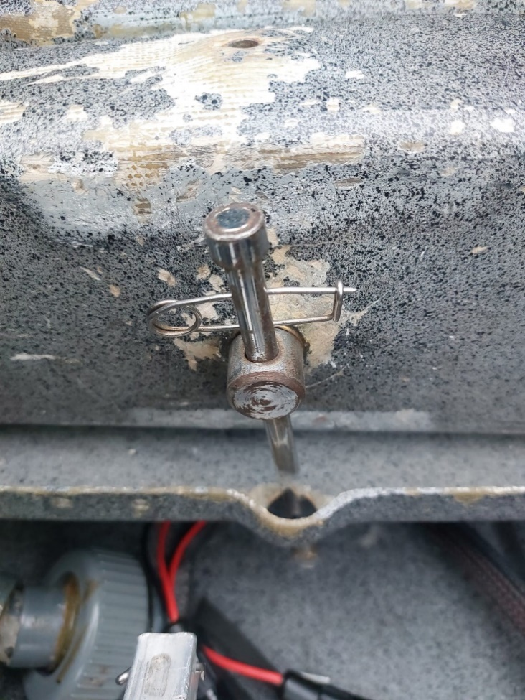 | 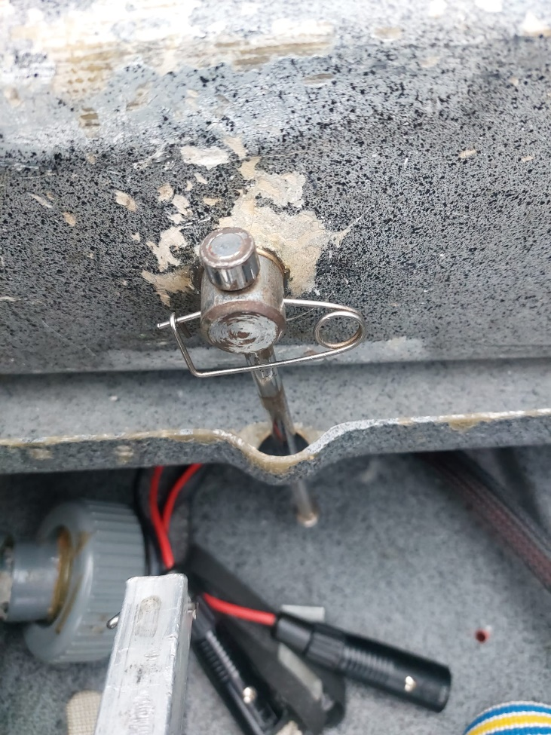

- Securing of Castellated Nuts
Some connections need to be secured against rotation. In most of the cases, this is achieved by the use of a castellated nut and a Fokker-needle. The pin of the needle must be pushed through two castells and a hole inside the screw.

- Manual Connections of Controls and Attachment of Horizontal Stabilizer
Sailplanes requiring manual connection of controls are noticeable in accident statistics due to controls left not connected. Pilots may forget to connect the manual connections of controls after the attachment of the wings (successful rigging of wings favours relaxation – “job done” feeling).
Similar scenarios may happen with horizontal stabilizers that have to be secured by a bolt, especially in cases where the application requires the use of a tool. Pilot attaches the horizontal stabilizer and walks away to collect the bolt and/or the respective tool. However, he/she may not return to finish the rigging and secure the horizontal stabilizer. Interruption and distraction are often contributing to these events.

Alexander Schleicher models
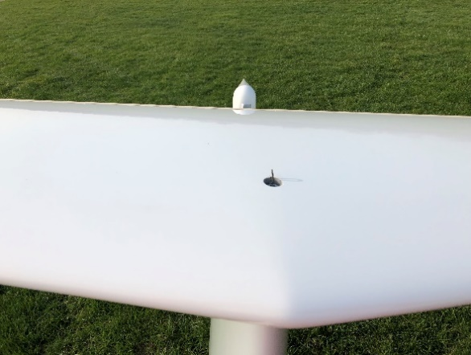 | 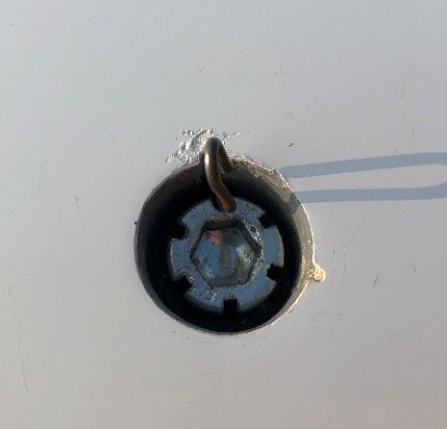
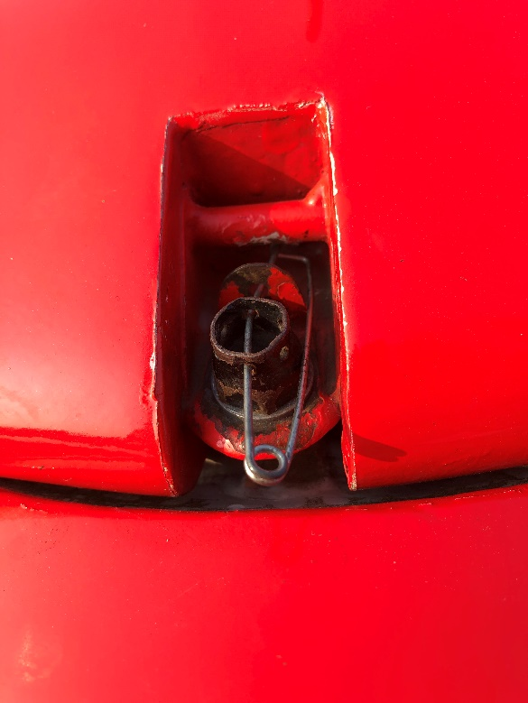 | The bolt needs to be engaged and secured against rotation.

Schempp-Hirth models
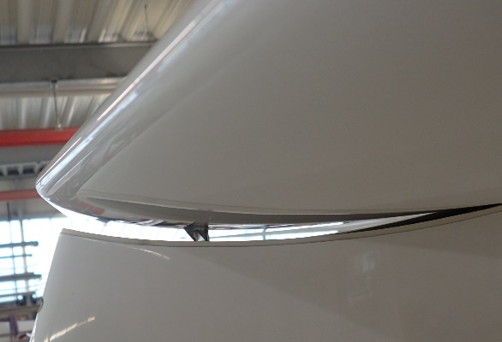 | Horizontal stabilizer enganged in its aft fitting but forward fitting not engaged.
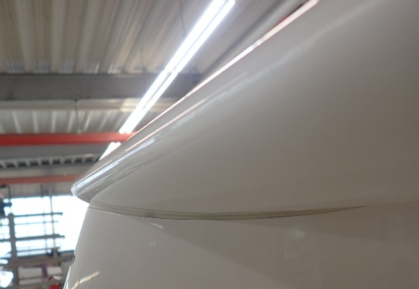 | Horizontal stablizer properly engaged.
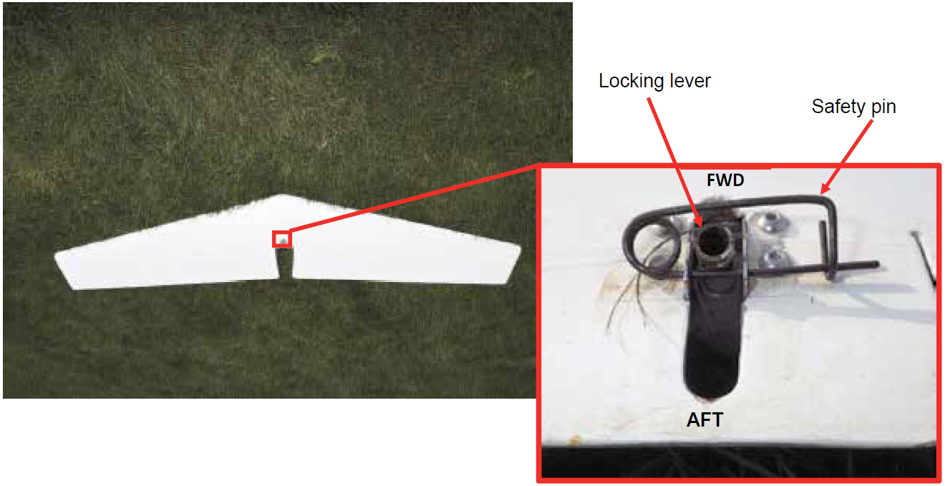  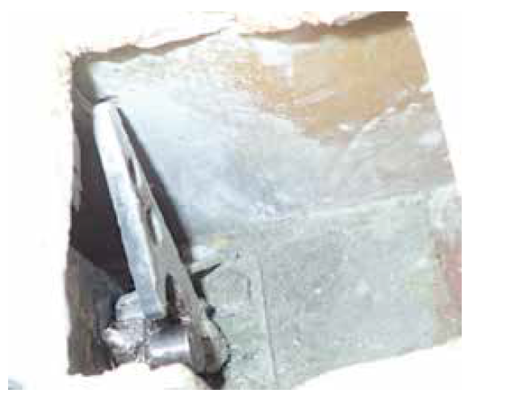 | Locking lever in the wrong – unlocked – position (on the wrong side of the Safety Pin).  In consequence, the looking hooks (left and right) are not enganged and the horizontal tailplane remains disconnected.
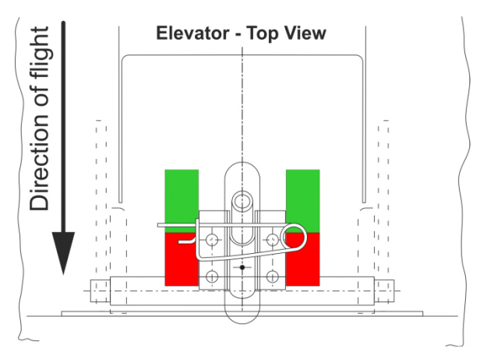 | EASA AD 2020-0260, requires the application of colour markings to indicate the correct locking lever alignment.  For details refer to Schempp-Hirth TN 278-40 rev. 1

Note: Not all cases of unconnected controls and unconnected horizontal stabilizers can be detected by performing a positive control check. Non-interruption during the rigging helps to prevent forgetting the connections in the first place. The checking of proper securing can be done by a visual inspection only.

- Securing of Manual Connections of Controls
The example below shows an aileron connection, which is typical for old sailplanes with manual control connections. In this case, the connection was engaged during rigging, but not correctly secured. After three flights of short duration, the bolt moved away from its engaged position.

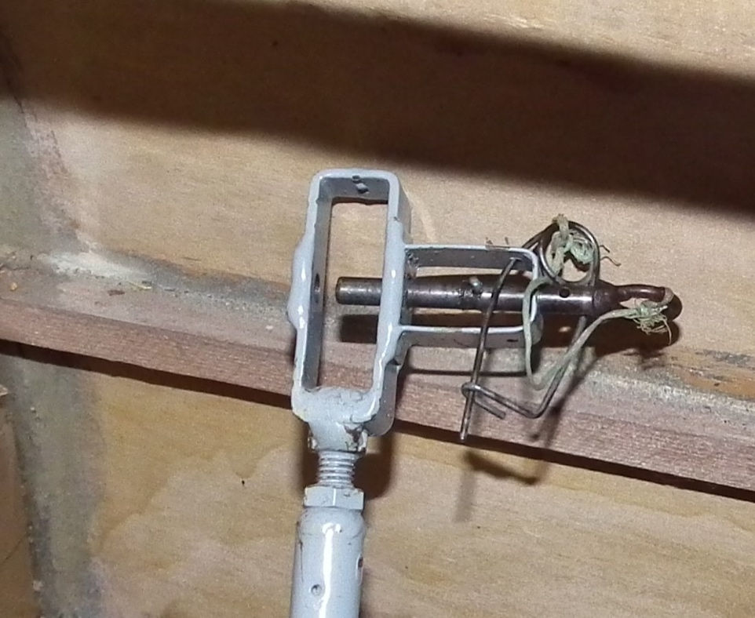 | The connection was not secured. The Fokker-needle was put through one hole of the cage only, but not through the bolt and the lower hole of the cage, as well. By this, the bolt could move freely, and the control connection could become unconnected.
 | The bolt is secured by pushing the Fokker-needle through all three holes.
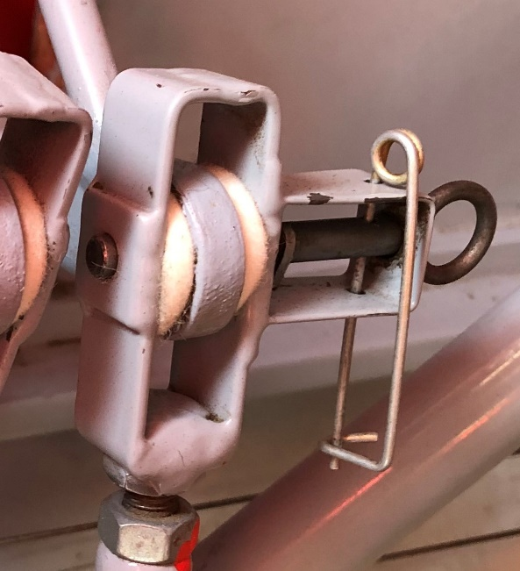 | A straight and not bended needle supports its proper application.

Note: Connections, which are not properly secured, cannot be detected by positive control checks. The proper securing can be verified only by a manual inspection through turning, pulling, or shaking of the bolt and further visual inspection.

- Automatic Connections of Controls
The typical automatic connection for the air brakes, ailerons, and flaps are located in the wing-to-fuselage joint. Those consist of a drive funnel inside the fuselage and a bell crank at the root rib of the wing. During assembly of the wing, it has to be ensured that the bell crank moves inside the drive funnel. Controls and control surfaces need to be in the positions as indicated by the flight manual, to ensure that the bell crank and drive funnels have the correct position to enable their proper connection.

Similar designs can be found for the control connection of the elevator. Pictures below show examples of a mis-rigged vertical stabilizer, which led to a fatal accident. The mis-rigging had its root cause in an unauthorized and apparently unrecorded modification, to make rigging easier.

SZD models
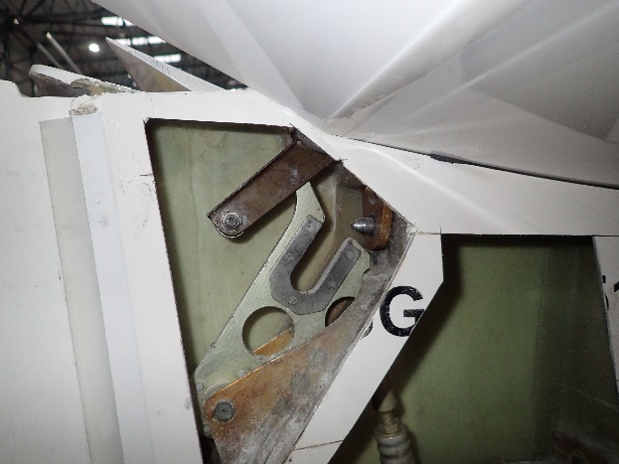 | 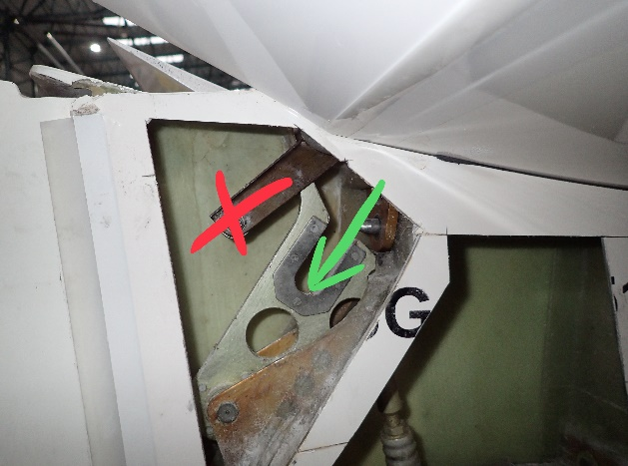
Disconnected elevator control | Disconnected elevator control

DG Aviation models
ls
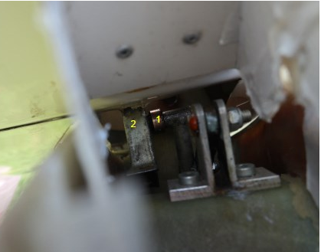
The roller at the fuselage side pushrod (1) is not inserted into the funnel (2) at the elevator

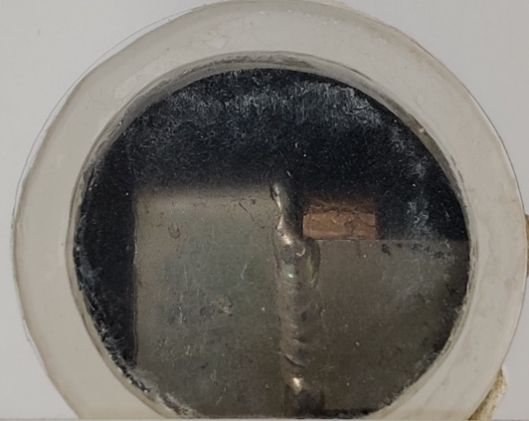 | Check for correct elevator connection by looking through the Plexiglas window at the upper surface of the stabilizer:  Elevator control connection is not performed correctly, if the roller is visible.
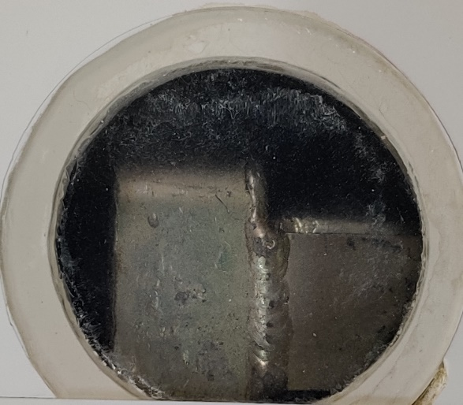 | Elevator control connection correct.  For details refer to DG Aviation, Service Info No. 111/23
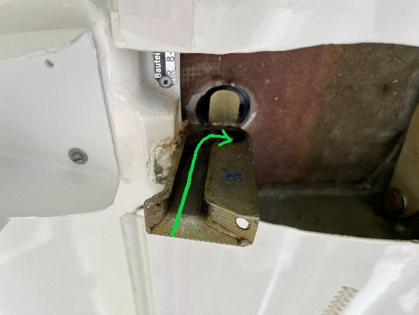 | The roller has to move into this funnel.
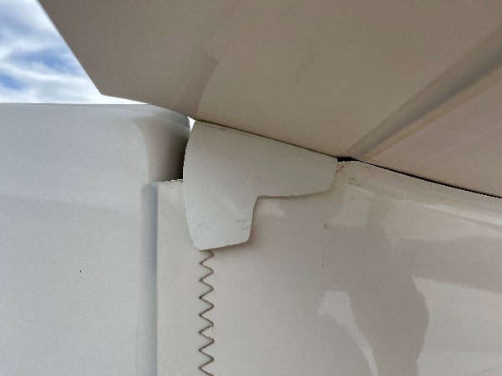 | Movement impaired by misplaced bracket. Roller most likely not in correct position.

Note: Those examples of rigging errors can usually be detected by a proper positive control check as indicated above.

- L´Hotellier Ball and Swivel Joint Quick Connectors
A number of rigging accidents have involved the l’Hotellier quick connectors found in many popular sailplanes. While in many cases the connections had simply been forgotten, in others the pilot had made the connections incorrectly.
L’Hotellier connections rely upon proper engagement of a ball and socket, which are secured by a spring-loaded tab that must be pressed out of the way to make the connection. With the tab in position, a witness hole is exposed, allowing a locking pin/clip to be fitted to secure the connection. The controls can become disconnected in flight, if the pin is not fitted.
Unfortunately, the tab adopts a similar position when the ball and socket are completely disconnected and, although the ball is then locked out of the socket, it may in some cases engage sufficiently for the controls to seem connected. Being able to insert the locking pin does not guarantee that the connection has been properly made.

It is crucial to check that the ball and socket are correctly engaged. This can be difficult, if access is tight or illumination poor; a torch and mirror, or telephone camera, can help.

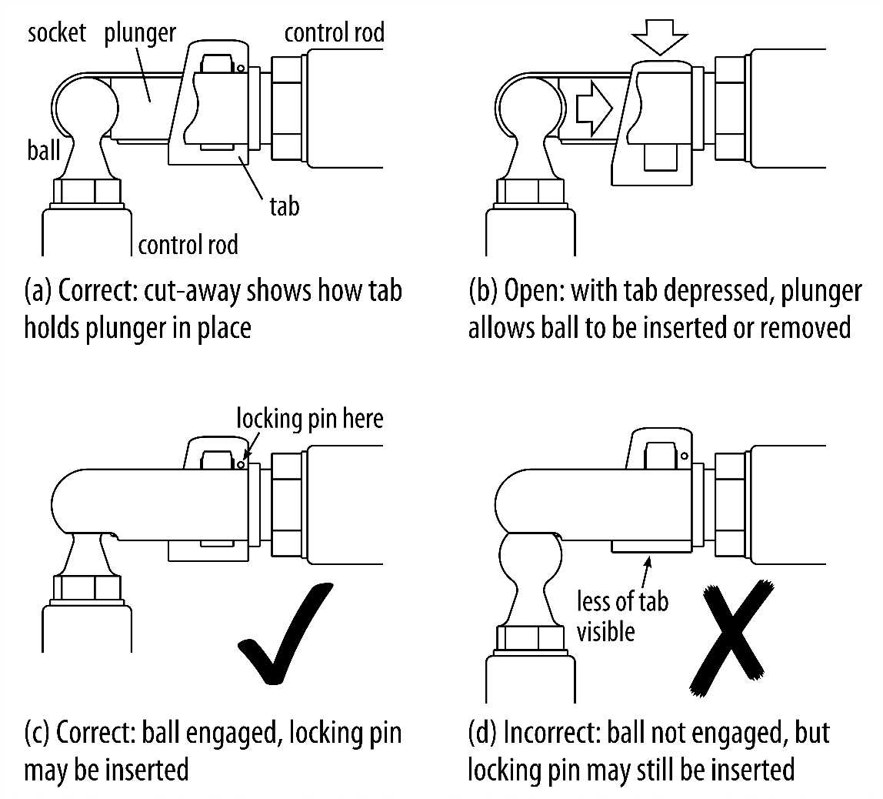

There are several common modifications to dispense with the locking pin.

 | The Wedekind locking sleeve slides outside the l’Hotellier fitting to secure the tab, but does not necessarily prevent partial engagement.
 | The Uerlings sleeve and similar threaded sleeve used on LS-sailplanes rotate or unscrew over the coupling and cannot be moved into position, if the ball and socket are only partially engaged.
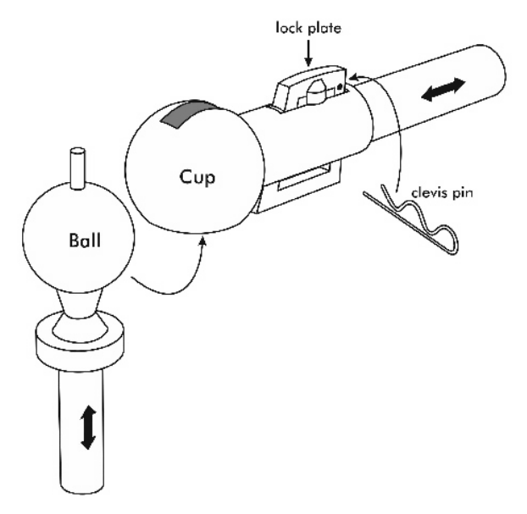  Socket | Newer l’Hotellier connectors come with a pin on the top of the ball that becomes visible outside the socket, once the ball and socket are properly engaged. The pin allows also for a tactile inspection. The connection still needs to be secured.

Remark: The maintenance instructions of l’Hotellier, in particular about ball wear need to be respected.

Note: To check the proper engagement of l’Hotellier connectors, a positive control check is strongly recommended.

- Expanding main pins of main wing connection
The wing rigging pins for most gliders are smooth cylinders, but those for e.g. the SZD-24/32 Foka, SZD-36 Cobra, SZD-8 Jaskółka, SZD-9 Bocian, Schempp-Hirth SHK and Schempp-Hirth Austria, consist of expanding pins/cones, which must be fitted exactly in accordance with the instructions of the flight manual. If the pin/cone is not correctly located, the wings can fold up and detach from the fuselage. Unless inspection holes have been cut for the purpose, it can be very difficult in some gliders to see whether the fitting has been assembled correctly.

Example of an expanding main pin wing connection.

Note: In case of sailplanes with expanding main pin wing connections, practice rigging should be carried out under the supervision of someone who is familiar with the sailplane type.

Retrofit of automatic control connections
In case automatic control connections are available as retrofit to a specific sailplane, it is strongly recommended to embody such modification. The risk of not connected or wrongly connected controls is significantly reduced by automatic control connections. The same is valid for improved attachments.

Safety Promotion
It is recommended that gliding communities develop training material and sessions on rigging procedures and typical mistakes observed. The material and training should provide a basic understanding of the design of standard connections and their proper operation. Local gliding clubs should provide rigging training tailored to the respective fleet in operation.
It is emphasised that rigging and derigging of sailplane is addressed in the syllabus for the training of students. A student should be able to command the rigging and derigging of a sailplane before issuance of the licence.

Contact(s):
For further information contact the EASA Safety Information Section, Certification Directorate.
E-mail: ads@easa.europa.eu

